Project
  - Deadline: Phase 1 (Mid project Progress Report) 26/07/2026 @ 23:59 Phase 2 (Final project Report) 9/8/2026 @ 23:59
[Total Mark is 20]

System Analysis and Design
IT-353

Instructions:
- You must submit two separate copies (one Word file and one PDF file) using the Assignment Template on Blackboard via the allocated folder. These files must not be in compressed format.
- It is your responsibility to check and make sure that you have uploaded both the correct files.
- Zero mark will be given if you try to bypass the SafeAssign (e.g. misspell words, remove spaces between words, hide characters, use different character sets, convert text into image or languages other than English or any kind of manipulation).
- Email submission will not be accepted.
- You are advised to make your work clear and well-presented. This includes filling your information on the cover page.
- You must use this template, failing which will result in zero mark.
- You MUST show all your work, and text must not be converted into an image, unless specified otherwise by the question.
- Late submission will result in ZERO mark.
- The work should be your own, copying from students or other resources will result in ZERO mark.
- Use Times New Roman font for all your answers.
Student Details: CRN:50268
Name: Bushra Alshayeb  Name: Gala Algodah  Name: Hessa Abdullah  Name: Maha Alsubaie  Name:SHATHA KHALED BAQAIS |  | ID: S240057076  ID: S240031741  ID: S240041770  ID:S240025765  ID:S240067735

Project submission guidelines and instructions
- Mid project Progress Report:
Students are required to submit a short mid progress report, which must include:
  - Work completed this period
  - One key decision has been made during this period
  - One problem encountered
  - Plan to do next.
  - Each group member input/participation.
  - A link to each group member GitHub repository
- Version History / Commit Log Requirements:
Each group member must complete and submit project history/timestamp using a live, editable GitHub link. The repository must show commit history reflecting incremental progress. commit regularly (at minimum once per week), with clear, descriptive commit messages.
A separate section in the report must be added and named “Project Artifacts" to include each student’s name and a link to his/her GitHub repository (with commit history).
What NOT to do: Students must not write their report elsewhere and paste the final version in at the last minute. They also should not make a single commit containing your entire files. Both are treated as red flags regardless of the quality of the final work.
- Written Reflection (End of Project Report):
The project report should include a Reflection section (300–500 words) as the last section (one section for each student). This section must be written in students’ own words and should address some of the following:
  - Describe one specific challenge or obstacle you encountered during this project and explain in detail how you identified and resolved it.
  - Explain why you chose your specific approach/method/model over at least one alternative you considered, and what tradeoffs informed that decision.
  - If you used any AI tools during this project (e.g., ChatGPT, Claude, Copilot), disclose which tool(s), for what specific purpose (e.g., debugging, grammar checking, brainstorming), and how you verified or modified the output.
  - What would you do differently if you were to redo this project with more time or resources?

Important Notes
- AI use: Students may use AI tools (ChatGPT, Claude, Copilot, Gemini, etc.) only for brainstorming approaches, debugging small errors, or proofreading text. AI must not be used to generate analysis, write code logic, or produce substantial portions of report or codebase. Any permitted AI use must be disclosed in Reflection section. Undisclosed AI use, or AI use beyond this scope (disclosed or not), will result in a zero grade for the entire project.
- Any submission lacking a valid, inspectable version/commit history, or showing evidence of AI generation or plagiarism, will receive a zero grade for the entire project.
- Failure to submit mid progress reports as required, or submission of reports found to be fabricated, copied, or AI-generated, will result in a zero grade for the entire project.

Project Rubric

Component | Weight | Note
Final report/deliverable | 85% | Core assessment of the work itself.
Mid Progress report | 10% | Incentivizes engagement across the timeline, not just at the end. Absence blocks credit for the whole project.
Version/commit history | Pass/fail | Not a grade component. Absence blocks credit for the whole project.
Reflection section | 5% | Rewards demonstrated understanding and honest disclosure.

Scenario

The Saudi Electronic University (SEU) currently organizes a wide variety of extracurricular activities, including workshops, seminars, competitions, volunteering opportunities, social events, career development sessions, and sports activities. However, information about these activities is scattered across emails, social media platforms, and announcements, making it difficult for students to discover upcoming events and register for them. Activity organizers also face challenges in managing registrations, tracking attendance, monitoring participation limits, and preparing reports.
Learning Outcome(s):
Illustrate most common analysis and design techniques in the form of a group project.

To address these issues, SEU plans to develop a Student Activities Management System (SAMS) that will provide a centralized platform for managing all student activities. The proposed system should allow students to browse available activities by category, campus, or date, view detailed information about each activity, reserve a seat, cancel a reservation before the registration deadline, receive notifications and reminders, and record their attendance by scanning a QR code or using another electronic attendance method at the event. Students should also be able to view their personal activity history throughout their studies, including the number of activities attended, participation hours, certificates earned, and achievements. Upon graduation, the system should automatically generate a comprehensive Student Activity Report (Activity Transcript) summarizing all extracurricular activities completed during the student's academic journey.
Activity organizers should be able to create, edit, publish, and cancel activities, define participant limits, registration periods, locations (physical or virtual), attendance methods, and eligibility requirements. Organizers should also manage participant lists, approve registrations when required, record attendance, issue participation certificates, and generate reports on attendance rates and student engagement.
The Student Affairs Department should oversee the entire system by managing activity categories, approving activities submitted by organizers, monitoring participation statistics across all university branches, generating institutional reports, and ensuring that each student's activity transcript is accurate and complete before graduation.
The system should also support notifications for registration confirmations, activity reminders, cancellations, and waitlist updates. If an activity reaches its maximum capacity, additional students should automatically be placed on a waiting list and promoted when vacancies become available.
The university expects the new system to improve student engagement, simplify activity management, eliminate manual attendance tracking, and provide accurate records of students' extracurricular involvement throughout their university studies.
Based on the above scenario, complete the following tasks.

Task 1
Develop a Gantt Chart for the project, including major development activities, durations, and dependencies. [1.5 marks]

Gantt Chart

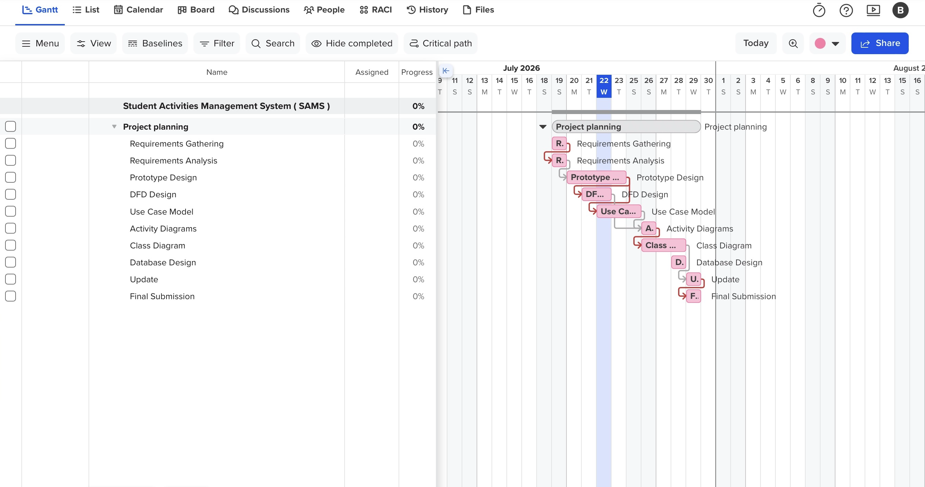

Reflection:

When I first started this project , I thought creating a Gantt chart would be simple. I expected it to involve just adding tasks with dates, but once I began using TeamGantt, I realised there was much more to it. I had to think carefully about the order of each task, estimate realistic durations, and connect the activities using dependencies. At the beginning, I made several mistakes with the dates and task relationships, which made the schedule look confusing. Instead of giving up, I went back, reviewed everything, and kept improving it until it made sense.

Another challenge was working with the project deadline. I had to adjust the schedule several times because I wanted all the tasks to finish before the submission date while also taking weekends into account. This taught me that effective planning is flexible and sometimes requires making changes until everything fits together logically, and that small adjustments can prevent bigger problems.

Using TeamGantt was a new experience for me. At first, I found the interface confusing, especially when adding dependencies and adjusting task durations. However, after spending more time practising, I became more comfortable with it. By the end of the assignment, I felt much more confident and understood how project management tools help organise work and track progress.
Overall, this assignment taught me more than how to create a Gantt chart. It showed me the importance of planning before starting any project, thinking logically about task sequences, and paying attention to detail. I believe these are practical skills that I can use not only in my university projects but also in my future career, especially when managing teams and deadlines. Looking back, I am satisfied with the final result because I learned something new and improved my problem-solving and planning skills throughout the process.

Task 2
- Select ONE prototyping approach
- (Evolutionary Prototyping or Throwaway Prototyping).
- Develop low-fidelity prototypes for 3 main screens
of the system and justify why your chosen approach is more appropriate for this project. [2 marks]
Selected Prototyping Approach

- Evolutionary Prototyping

Justification

Evolutionary Prototyping was selected because it allows the system to be improved step by step based on user feedback. Since the Student Activities Management System includes different features such as browsing activities, registration, notifications, attendance tracking, and activity management, this approach is more suitable. It helps the team understand user needs better, make improvements during development, and reduce the chance of creating a system that does not meet user expectations.

Low-Fidelity Prototype Screens

Screen 1: Home
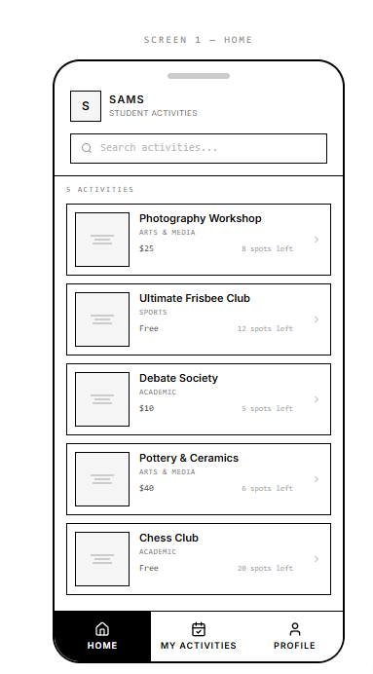

Screen 2: My Activities
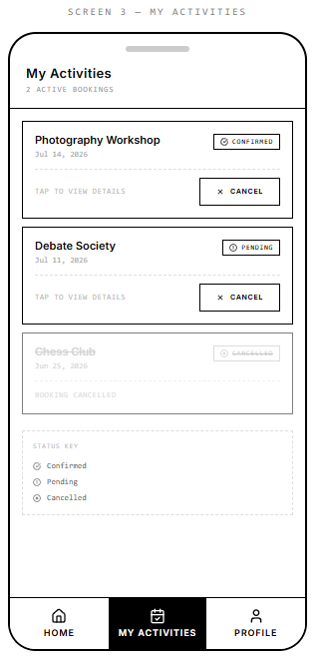

Screen 3: Activity Details & Registration
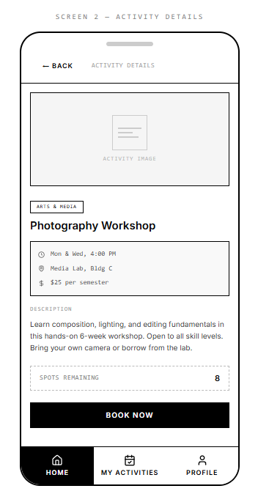

Reflection:

Working on Task 2, which involved designing the low-fidelity prototype, was a valuable experience for me. My responsibility was to choose a suitable prototyping approach, design three main screens for the Student Activities Management System, and explain why the selected approach was appropriate. This task helped me understand that interface design is not only about making the screens look good, but also about making them simple and easy for users to use.

The biggest challenge I faced was creating the prototype itself. At first, I found it difficult to decide where to place each element and how to organise the screens in a clear and simple way. I spent time changing the layout several times until I was satisfied with the final result. Although it was challenging, I enjoyed the process. When I finally saw the completed prototype, I felt proud because it felt as though I had created something new from my own ideas. I even wished I could add colours and make it look more realistic, but since the project required a low-fidelity prototype, I kept the design simple and focused on the structure instead.

I chose Evolutionary Prototyping instead of Throwaway Prototyping because I believe it is more suitable for this project. The Student Activities Management System contains different features, such as browsing activities, viewing details, and registering for events. These features may need further improvement after receiving user feedback, so Evolutionary Prototyping allows the design to be updated and refined gradually without starting over. In contrast, Throwaway Prototyping is mainly used to explore ideas and is usually discarded once the requirements are clear. For this reason, I believed Evolutionary Prototyping was the better choice.

During this project, I used ChatGPT only as a supporting tool. I used it to help me understand some project requirements, improve the grammar of my writing, and organise my ideas more clearly. I did not copy the responses directly. Instead, I reviewed the suggestions carefully, compared them with the project instructions, and rewrote the content in my own words to ensure it reflected my understanding and matched the project requirements.

If I had more time, I would create additional prototype screens and ask other students to test the interface before the final submission. Their feedback would help me improve the design and make the user experience even better. Overall, this project improved my design skills and gave me more confidence in creating user interfaces. It was a challenging but enjoyable experience, and I am pleased with what I achieved.

Task 3
Develop the Data Flow Diagrams (DFDs):
- Context Diagram
- Level-0 DFD
- Three Level-1 DFD for 3 major processes [2.5 marks]

Context Diagram: 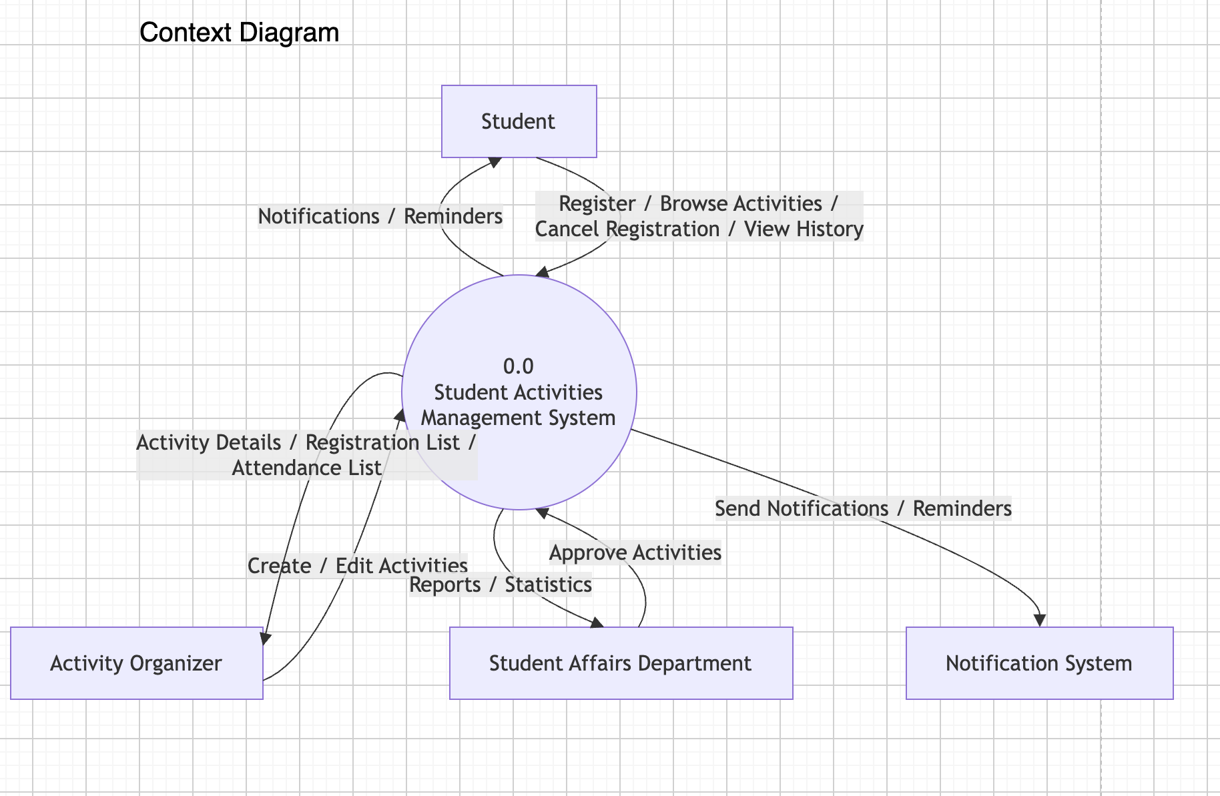

Level-0 DFD : 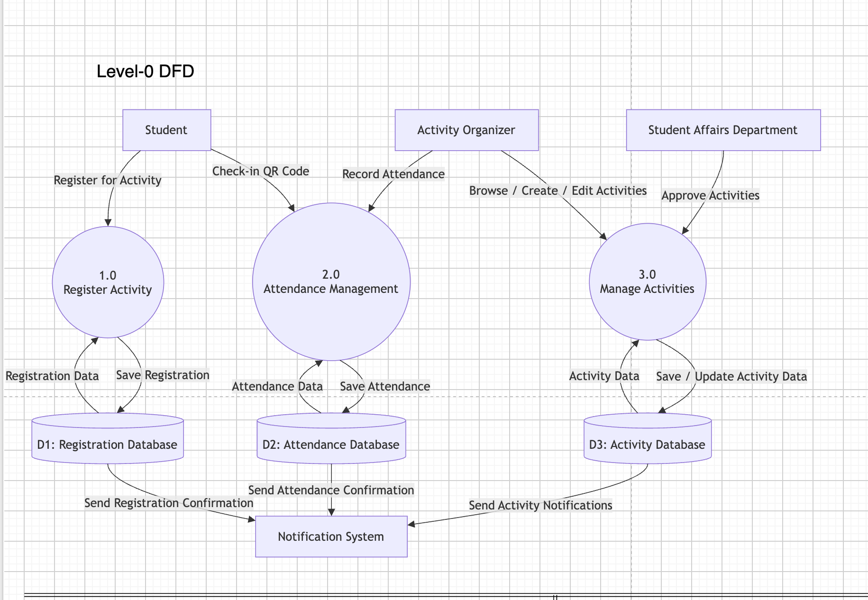

Level-1 DFD: Process 1.0
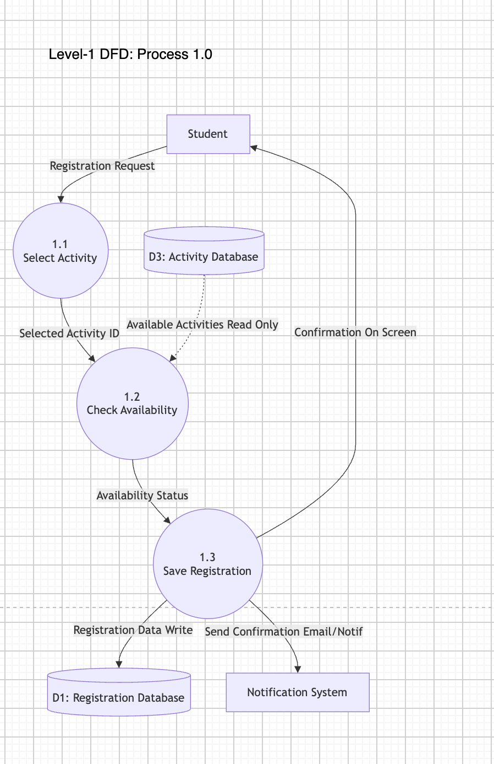

Level-1 DFD: Process 2.0:
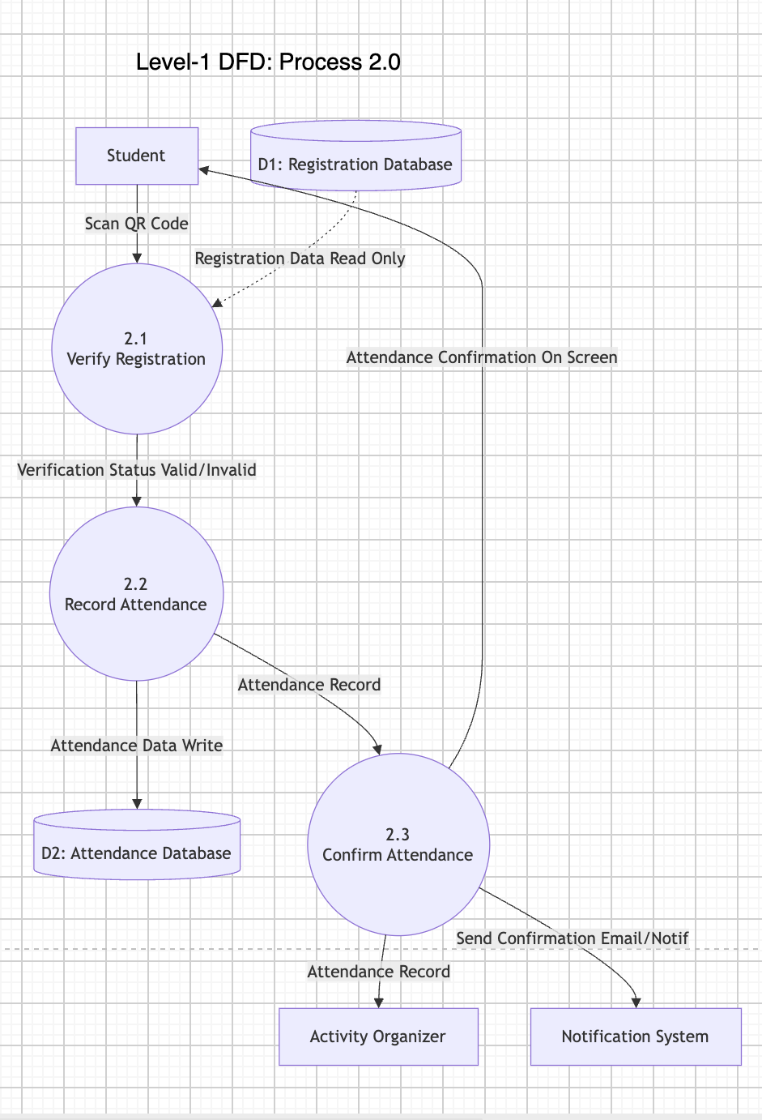

Level-1 DFD: Process 3.0:
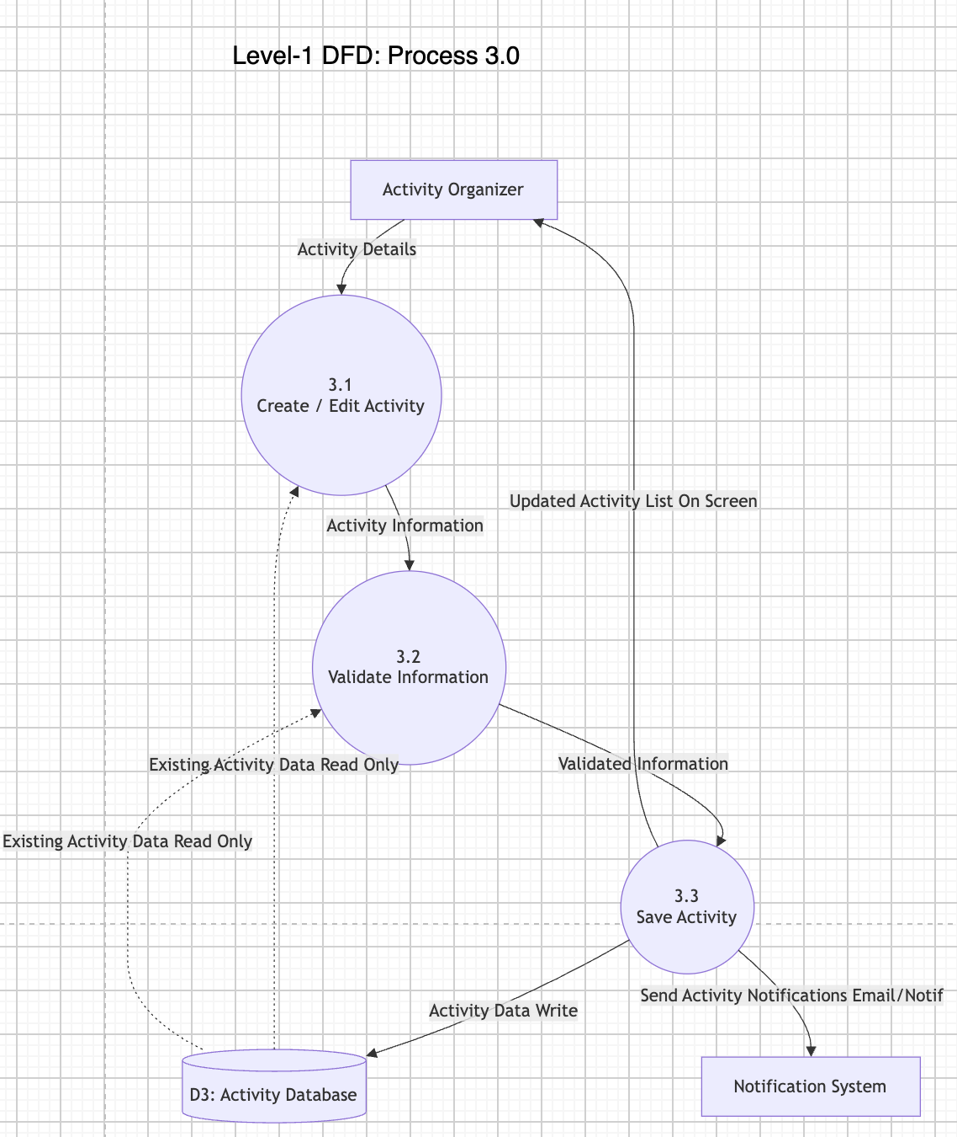

Reflection:

Working on Task 3 of the Student Activities Management System (SAMS) project was a valuable hands-on experience that significantly deepened my understanding of functional modeling and data flow analysis. Over a period of about a week, my main responsibility was to analyze the system requirements and translate them into a structured set of Data Flow Diagrams (DFDs), including the Context Diagram, Level-0 DFD, and three detailed Level-1 DFDs for the major system processes.

One of the most significant challenges I faced during this task was ensuring proper balancing and consistency across the different diagram levels. Initially, I struggled to correctly map the data inputs and outputs between external entities and data stores without creating redundant flows. For instance, differentiating between read-only data accesses and write operations for the Activity, Registration, and Attendance databases required careful attention. I noticed this problem when reviewing my early sketches, where the connections appeared cluttered and hard to follow. To solve this, I systematically reviewed standard Gane-Sarson notation rules, broke down each process into distinct subprocesses, and double-checked that all incoming and outgoing data flows matched across the Level-0 and Level-1 diagrams.

Another key decision was choosing draw.io to build the final diagrams instead of basic drawing tools. Although setting up the diagrams in draw.io required extra effort to properly align shapes,Organizing curved connectors and maintaining standard DFD symbols was a tradeoff well worth it. It allowed me to produce clear, highly accurate, professional models that accurately represent the system architecture.

If I had more time to redo this project, I would conduct a peer review session with campus activity managers earlier to validate the data flow logic against real-world operations. Overall, completing this task significantly enhanced my skills in visual system design, logical process mapping, and technical problem-solving.

Task 4
Develop the Use Case Model:
- Identify all system actors.
- Create one complete Use Case Diagram.
- Fully document three use cases using the use case template. [3 marks]

System Actors :
Based on the Student Activities Management System ( SAMS ) scenario , the actors interact with system :

Student: Browses and registers for activities, cancels reservations, records attendance electronically, and views personal activity history and transcripts.

Activity Organizer: Creates, edits, and publishes activities, sets participant limits and registration periods, manages participant lists, records attendance, and issues certificates and reports.

Student Affairs Department: Oversees the entire system, manages activity categories, approves or rejects submitted activities, and monitors institutional statistics and student transcripts.

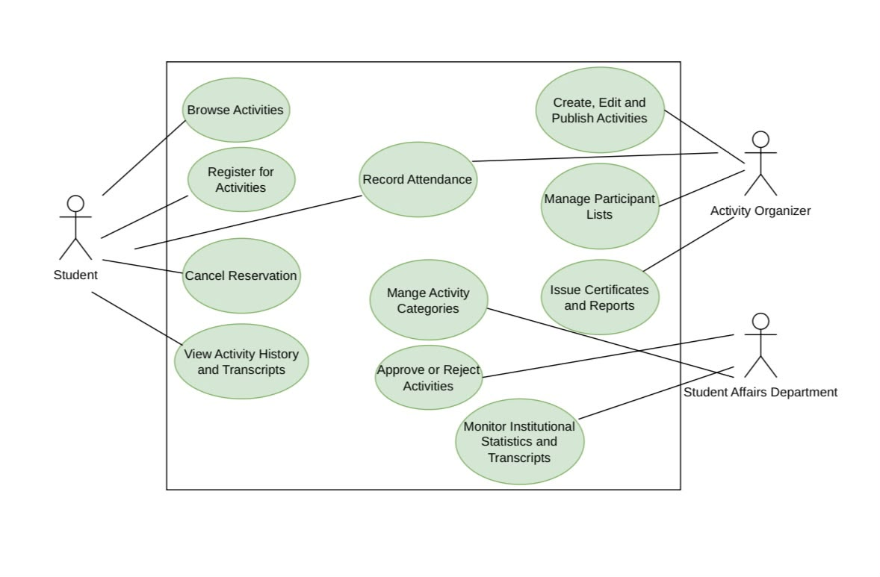

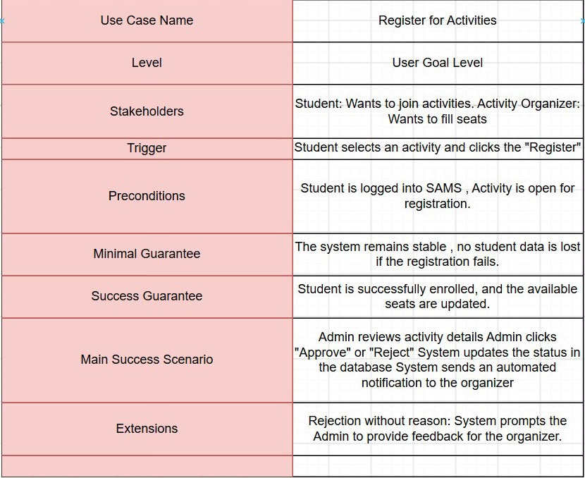
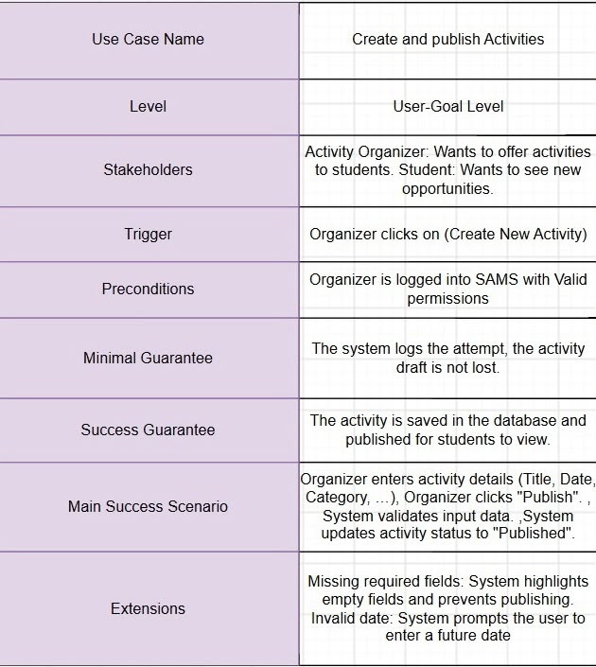
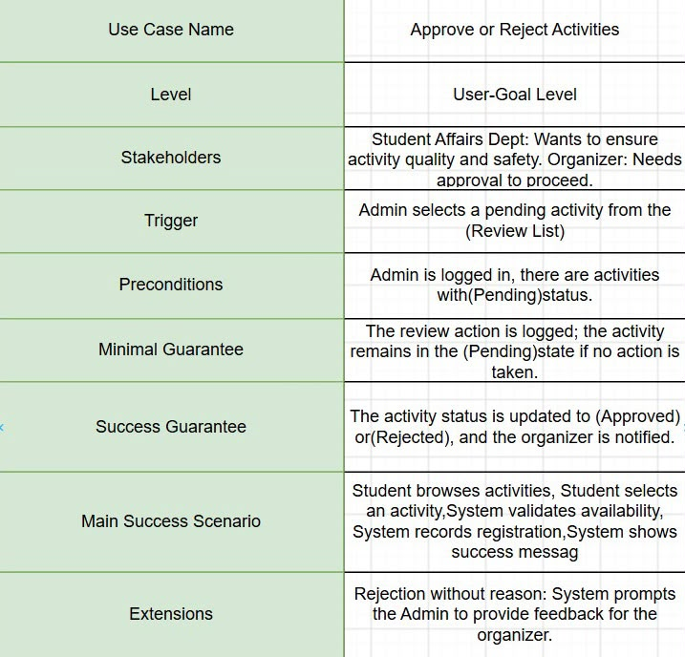

Reflection:

Use Case Documentation and Design Implementation
During this phase of the project, my primary individual focus centered on translating core functional requirements into standardized use case descriptions and structured graphical tables for the Student Activities Management System (SAMS). This development milestone marked a critical transition from abstract system concepts to concrete, academically compliant design documentation, ensuring that all user interactions and system workflows are rigorously defined according to professional software engineering standards.
The hands on implementation process involved developing, refining, and formatting three major operational use cases: Register for Activities, Create and Publish Activities, and Approve or Reject Activities. To ensure full compliance with rigorous system analysis methodologies, I structured each process using a comprehensive template. This required explicitly defining critical system boundaries and operational parameters, such as precise Triggers, Preconditions, Minimal Guarantees, and Success Guarantees. Doing so guaranteed that expected system behaviors are fully accounted for under both standard operational flows and complex exception handling scenarios.
Furthermore, incorporating detailed extension scenarios,such as handling registration validation, enforcing input requirements, and mandating administrative feedback during activity rejections significantly enhanced the logical integrity and robustness of the documentation. From a technical execution standpoint, utilizing advanced diagramming tools allowed me to present these workflows through clean, organized visual tables. Structuring the fields carefully ensured high readability and a clear separation of responsibilities among system actors, including students, activity organizers, and the student affairs department. Refining these text based use case specifications also helped clarify the exact state transitions and database interactions required for each individual feature, ensuring that every edge case is properly mapped out.
Overall, this task successfully bridged the gap between theoretical systems analysis and practical application, reinforcing the importance of precise technical documentation and systematic workflow design. These finalized use case templates will serve as a solid, reliable blueprint for subsequent design and implementation phases, ensuring structural consistency across the entire project lifecycle

Task 5
Develop two UML Activity Diagrams for two major business processes. [2 marks]

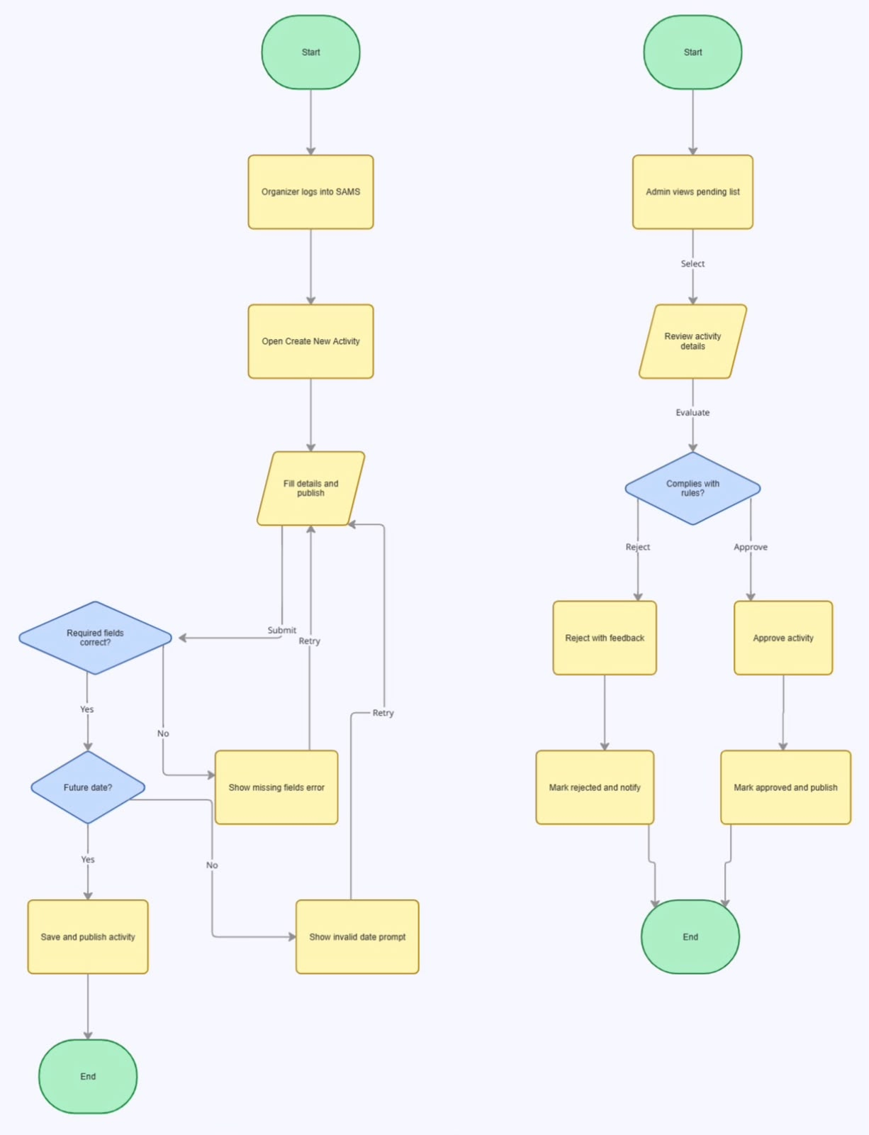

Task 6
Develop a UML Class Diagram including classes, attributes, methods, associations, multiplicities, and inheritance where appropriate. [3 marks]

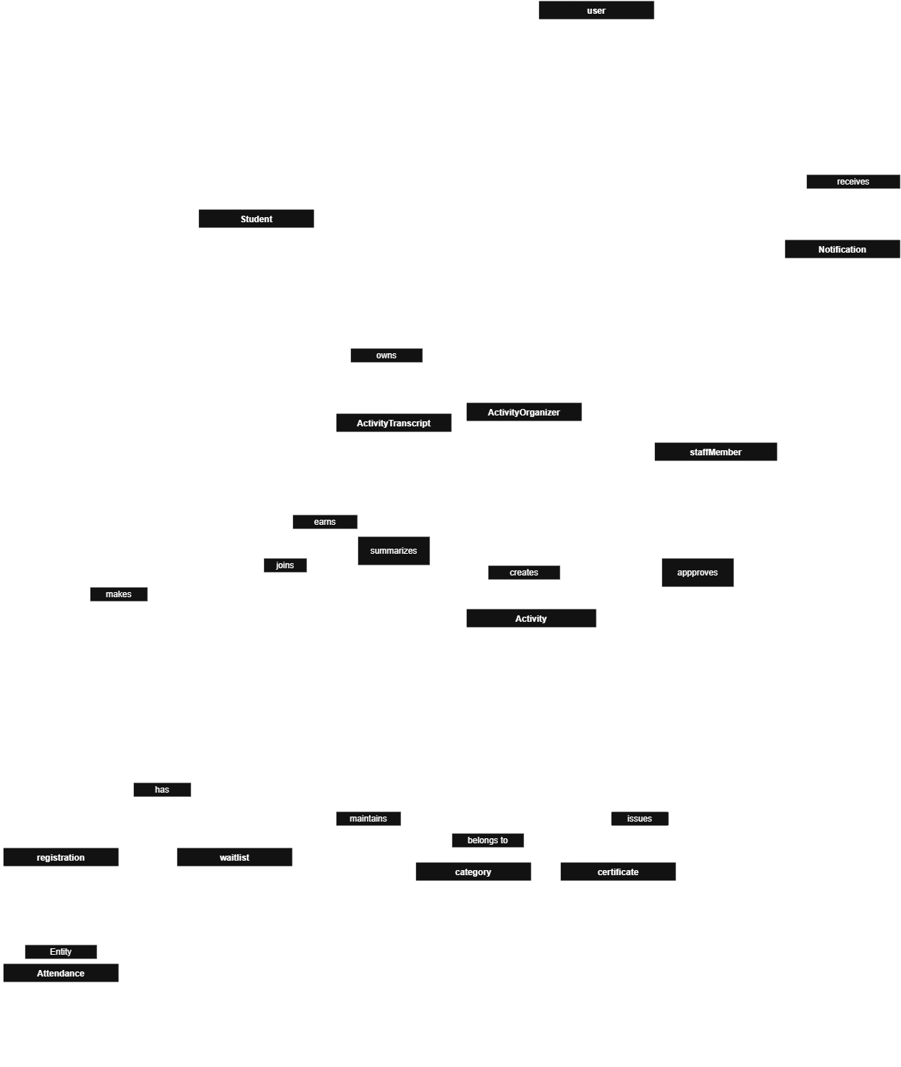
Reflection :

Working on the UML Class Diagram for the Student Activities Management System (SAMS) was a valuable learning experience that improved my understanding of object-oriented analysis and design. Before starting this task, I had only a basic understanding of UML diagrams. However, creating the class diagram helped me understand how different system components are organized and how they interact with each other.
The first step was identifying the main classes required by the system based on the project requirements. These included classes such as User, Student, Activity, Activity Organizer, Staff Member, Registration, Attendance, Certificate, Notification, Category, and Activity Transcript. After identifying the classes, I defined the attributes and methods for each one. This process helped me understand the responsibilities of each class and how object-oriented concepts can be applied to represent real-world entities in a software system.
One of the most challenging parts of the task was determining the relationships between the classes. I had to carefully decide when to use associations and inheritance and identify the correct multiplicities for each relationship. For example, I needed to represent that a student can register for multiple activities while each registration is linked to only one activity. Understanding these relationships required careful reading of the project description and attention to detail.
Creating the diagram also improved my problem-solving skills. I learned that designing a system is not only about writing code but also about planning the system structure before implementation. A well-designed UML Class Diagram makes it easier for developers to understand the system, communicate ideas within a team, and reduce errors during development. I also realized that a clear design can save time in later stages of the software development process.
Another important lesson I learned was the importance of organizing information logically. Dividing the system into classes with clear responsibilities makes the design more readable, maintainable, and scalable. This task also increased my confidence in using UML diagrams as a modeling tool for software engineering projects.
Overall, completing this task enhanced my understanding of object-oriented design principles and the role of UML Class Diagrams in software development. It strengthened my analytical thinking, improved my ability to model complex systems, and gave me practical experience that will be useful in future software engineering and system analysis projects.

Task 7
Design the relational database, including tables, primary keys, foreign keys, appropriate data types, and normalization (up to at least Third Normal Form). [3 marks]

